**IDEATION PHASE**

**BRAINSTORM & IDEA PRIORITIZATION**

|  |  |
| --- | --- |
| **Date** | 16th June 2025 |
| **Team ID** | LTVIP2025TMID29987 |
| **Project Name** | CRM Application for Jewelry Management – (Developer) |
| **Maximum Marks** |  |

**Objective:**

Brainstorming creates a collaborative, open environment where all ideas are welcome and encouraged. It allows a team to generate multiple creative solutions, group and prioritize them based on feasibility and impact.

**Step 1: Team Gathering, Collaboration and Problem Identification**

The team came together to identify and understand challenges in the traditional jewelry store management system. Observations and interviews with staff and small business owners were conducted to discover real-life problems in:

* Tracking customer orders
* Manual billing and payments
* Lack of automation
* Inability to manage gold/silver items efficiently

**Selected Problem Statement:**

**"Jewelry stores lack a centralized system to manage inventory, orders, billing, and customer communication efficiently."**

**Step 2: Brainstorming, Idea Listing and Grouping**

Raw Ideas Collected:

* Automate billing process
* Send email notifications after billing
* Track gold/silver item details separately
* Record customer orders and payment history
* Implement record types and profiles (Goldsmith, Worker)
* Dashboard to view customer and billing insights
* Create reports (Billing, Order, Customer)
* Validation rules to avoid errors
* Flow for sending customer email

**Grouped Ideas:**

1. **Automation**
   * Billing updates trigger email
   * Auto calculation of paid amount
2. **Inventory Management**
   * Track item types (gold/silver)
   * KDM and stone charges
3. **Role-Based Access**
   * Profiles for Goldsmith, Worker
   * Permission sets
4. **Reporting & Visualization**
   * Custom reports: Orders, Billing
   * Dashboard for key metrics
5. **User Communication**
   * Email notification flow
   * Email error handling

**Step 3: Idea Prioritization**

|  |  |  |  |
| --- | --- | --- | --- |
| **Idea** | **Impact** | **Feasibility** | **Priority** |
| Auto email on billing | High | Medium | High |
| Track paid amount | High | High | High |
| Role-based permissions | Medium | High | Medium |
| Separate item record types | High | Medium | High |
| Dashboard creation | Medium | Medium | Medium |
| Validation rules | High | High | High |

**Final Shortlisted Ideas :**

Here are the final shortlisted ideas for the CRM for Jewel Management, with even more in-depth explanations of their functionality, technical considerations, and comprehensive benefits:

1. **Auto Calculation and Update of Paid Amount:**

This feature is the cornerstone of financial efficiency within the CRM. It automates the entire sales transaction process, significantly reducing manual effort and minimizing human error.

* **Automated Invoice Generation:** The system will instantly generate professional invoices for both single-item and multi-item purchases. This includes handling complex scenarios like custom orders, layaways, and installment plans, ensuring that all charges are accurately itemized.
* **Dynamic Tax Calculation:** It will automatically calculate and apply Goods and Services Tax (GST) based on multiple pre-configured tax slabs applicable to different product categories or services (e.g., making charges, gold, silver, diamonds). This simplifies compliance and ensures correct billing.
* **Real-time Inventory Adjustment:** Upon completion of a sale, the CRM will immediately update stock levels in the inventory module. For custom orders, it can trigger a deduction of raw materials (e.g., specific grams of gold/silver) and update the status of semi-finished goods.
* **Payment Tracking & Reconciliation:** The system will accurately track partial payments, full payments, and pending balances. It can integrate with payment gateways (POS systems, online payment portals) to automatically reconcile received payments against invoices, providing a clear financial overview.
* **Layaway & Installment Management:** For high-value items, the system can manage layaway plans, recording initial deposits, scheduled payments, and due dates, automatically notifying staff and customers of upcoming installments.
* **Benefit:** Dramatically improves accounting accuracy, accelerates checkout processes, enhances cash flow visibility, and reduces administrative overhead. It provides a reliable financial ledger for auditing and reporting.

1. **Record-Triggered Flow to Send Email:**

This robust automation feature transforms customer communication from reactive to proactive, ensuring timely and personalized engagement.

* + **Workflow Automation Engine:** This is powered by a configurable workflow or process automation engine (e.g., Salesforce Flow, HubSpot Workflows, custom-built logic). This engine listens for specific "record triggers" – changes or creations in data records.
  + **Event-Based Triggers:**
  + **Purchase Confirmation:** Automatically send a personalized "thank you" email with order details, estimated delivery/pickup dates, and care instructions immediately after a purchase is recorded.
  + **Order Status Updates:** Notify customers when their custom order moves from "designing" to "in production," "ready for pickup," or "shipped."
  + **Repair Status Alerts:** Inform customers about the progress of their jewelry repair (e.g., "Repair Started," "Parts Ordered," "Ready for Collection").
  + **Appointment Reminders:** Send automated reminders for consultations, custom fitting sessions, or maintenance appointments.
  + **Payment Reminders:** For layaway or installment plans, send automated reminders for upcoming payment due dates.
  + **Birthday/Anniversary Wishes:** Based on customer data, send automated celebratory emails with personalized offers.
  + **Dynamic Content Insertion:** Emails can be dynamically populated with customer-specific data (e.g., customer name, order number, item description, service date, balance due) from the CRM records, making each communication highly relevant.
  + **Error Handling & Logging:** The system should log all email attempts and successes/failures, providing insights into deliverability and allowing for re-attempts or manual follow-up if an email fails to send.
  + **Benefit:** Significantly improves customer satisfaction and retention through proactive communication, reduces manual workload for staff, and builds stronger customer relationships.

1. **Create Record Types for Gold/Silver Items (and other precious materials):**

This feature is fundamental for specialized inventory management within the jewelry sector, enabling granular control and detailed tracking of diverse product categories.

* + **Categorization Hierarchy:** Beyond just "gold" or "silver," the system can define specific record types or sub-categories such as:
    - * **Gold Items:** With fields for KDM (Karatage, Diamond, Making Charges), specific purities (22K, 18K), weight (gross, net), stone weight, making charges, hallmark details, and unique serial numbers.
      * **Silver Items:** Similar details but specific to silver purity (92.5%, etc.), weight, and design intricacies.
      * **Diamond/Gemstone Items:** Fields for cut, clarity, color, carat weight, certification (GIA, IGI), origin, and specific settings.
      * **Loose Stones:** Inventory for individual diamonds or gemstones not yet set in jewelry.
      * **Custom Orders (In-Progress):** Tracking raw materials consumed, progress stages, and specific customer requirements.
      * **Repairs:** Detailed records for incoming repairs, identifying the item, customer, defect, required work, and estimated completion.
  + **Tailored Fields & Layouts:** Each record type can have its own set of custom fields, unique page layouts, and specific validation rules, ensuring that relevant data is captured consistently for each type of item. For example, a "Gold Ring" record type would have fields for "Gold Purity" and "Hallmark ID," which would not be relevant for a "Loose Diamond" record type.
  + **Price Fluctuation Management:** The system can be configured to integrate with external feeds for real-time precious metal and gemstone prices, allowing for dynamic revaluation of inventory and ensuring that pricing is always up-to-date and profitable.
  + **Benefit:** Enables precise inventory control, accurate valuation, improved reporting on specific product categories, better management of raw materials, and streamlined repair processes. It provides a robust framework for managing the complex and high-value nature of jewelry stock.

1. **Custom Reports and Dashboards:**

These tools transform raw CRM data into actionable insights, empowering management and staff to make data-driven decisions and monitor performance effectively.

* + **Custom Report Builder:** A user-friendly interface that allows users to create highly specific reports by selecting data fields, applying filters (e.g., sales for June, customers who bought gold in Q1), grouping data, and defining sorting orders.
    - * **Examples of Reports:**
        + **Sales Performance Reports:** Daily/weekly/monthly sales by item category (gold, silver, diamond), by salesperson, or by location.
        + **Customer Behavior Reports:** Top spending customers, most frequently purchased items, customers due for an anniversary/birthday.
        + **Inventory Reports:** Stock levels by item type, slow-moving vs. fast-moving items, items nearing reorder points.
        + **Repair Service Reports:** Average repair time, number of ongoing repairs, most common repair types.
        + **Financial Reports:** Outstanding invoices, payment trends, revenue generated from custom orders vs. ready-made.
  + **Interactive Dashboards:** Visual representations of key metrics and report summaries. Dashboards provide a high-level, real-time "at-a-glance" view of business performance.
    - **Dashboard Components:** Can include charts (bar, pie, line), gauges, tables, and metric widgets displaying KPIs such as:
      * Total Sales (current month/quarter)
      * Number of New Customers
      * Average Order Value
      * Current Inventory Value
      * Open Repair Tickets
      * Sales Target Progress
  + **Drill-Down Capability:** Users can often click on a dashboard component to "drill down" into the underlying report for more detailed information.
  + **Scheduling & Sharing:** Reports can be scheduled to run automatically and be emailed to specific stakeholders. Dashboards can be shared with relevant teams or individuals.
  + **Benefit:** Provides invaluable insights into business performance, identifies trends and opportunities, facilitates performance tracking, aids in strategic planning, and enhances accountability across teams.

1. **Role-Based Access for Workers and Goldsmiths (and other roles):**

Role-Based Access Control (RBAC) is a critical security and operational efficiency feature that tailors the CRM experience to each user's specific responsibilities.

* + **Defined Roles & Profiles:** The system will allow the creation of distinct roles such as:
    - * **Sales Associate:** Access to customer records, sales transactions, order creation, limited inventory view (what's available for sale).
      * **Goldsmith/Artisan:** Access to production orders, raw material inventory, repair details, design specifications, but no direct access to financial reports or marketing campaigns.
      * **Inventory Manager:** Full access to inventory levels, reordering, supplier management, item creation/modification, but limited customer sales interaction.
      * **Store Manager:** Oversight of all operations within their store, access to sales performance, customer feedback, employee performance data for their branch.
      * **Administrator:** Full system access for configuration, user management, data migration, and global settings.
  + **Granular Permissions:** For each role, specific permissions can be set at various levels:
    - **Object Level:** Which types of records (e.g., Customers, Orders, Inventory Items) a user can see or interact with.
    - **Field Level:** Which specific fields within a record a user can view or edit (e.g., Sales Associates can see customer's name but not their credit score).
    - **Record Level:** Which specific records within an object a user can access (e.g., a Sales Associate only sees orders they created, or orders from their assigned customers).
    - **Action Level:** What actions a user can perform (e.g., "create order," "delete customer," "approve discount").
  + **Data Security & Compliance:** RBAC significantly enhances data security by preventing unauthorized access to sensitive customer data, financial records, or proprietary designs. It helps in meeting privacy regulations.
  + **Streamlined User Experience:** By hiding irrelevant information and functionalities, RBAC simplifies the user interface for each role, reducing clutter and making the system more intuitive and efficient for different users.
  + **Audit Trails:** Changes made by specific users can be tracked and attributed to their roles, providing an audit trail for accountability.
  + **Benefit:** Improves data security, ensures compliance, enhances operational efficiency by providing tailored access, simplifies user training, and boosts overall system integrity.

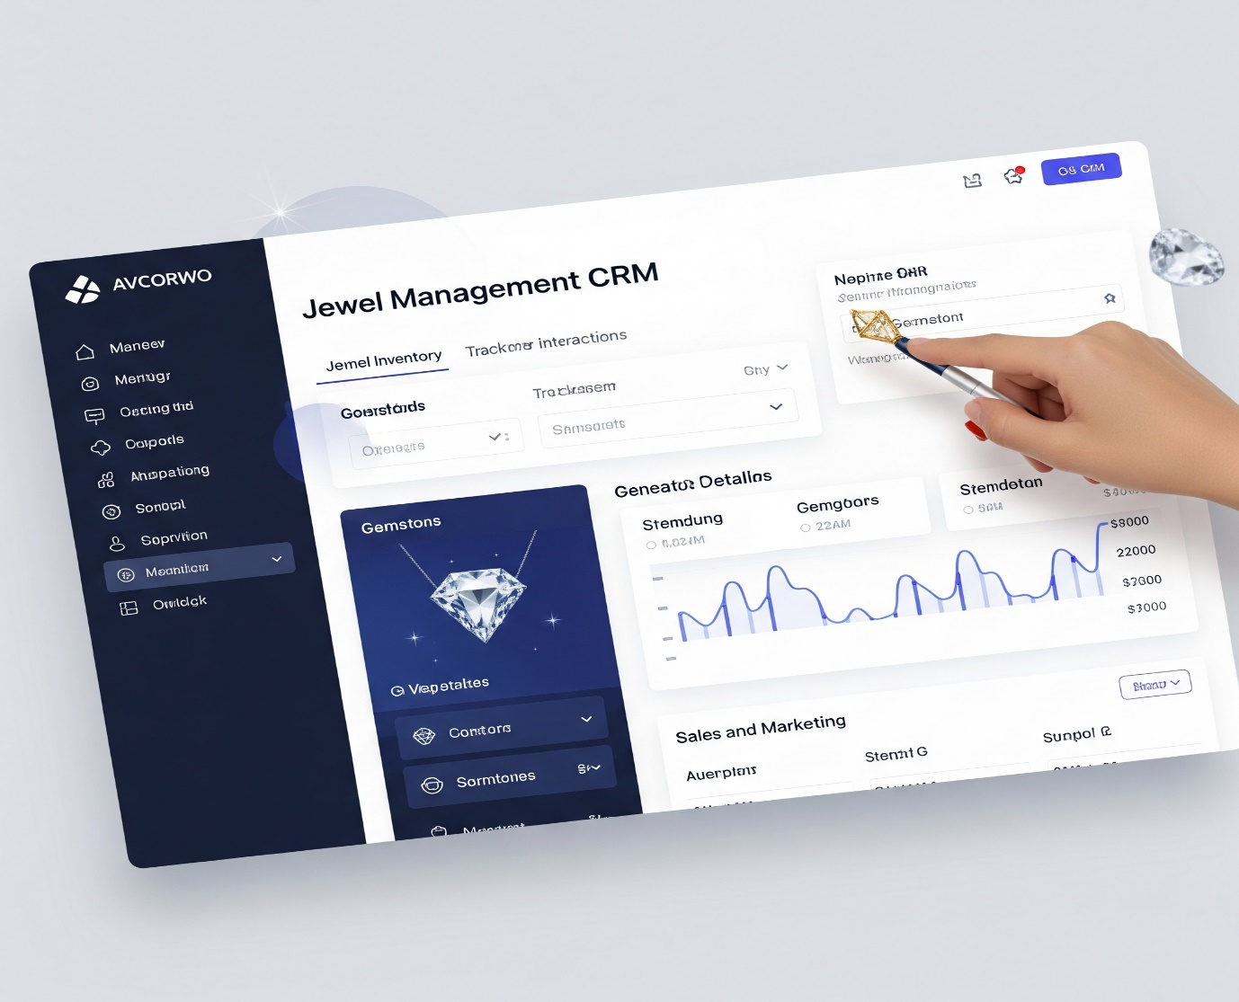

**EMPATHY MAP CANVAS**

The Empathy Map Canvas serves as a powerful tool to step into the shoes of your target users, understanding their world beyond just explicit requirements. By exploring what users say, think, do, and feel, we gain deeper insights into their needs, pain points, and motivations, which are crucial for designing a truly effective solution.

**Who are we empathizing with?**

Our primary target users for this CRM solution are:

* **Jewelry Shop Owners:** These individuals bear the ultimate responsibility for the business's profitability, customer satisfaction, and operational efficiency. Their concerns often revolve around overall business growth, financial tracking, inventory valuation, staff management, and ensuring a seamless customer experience. They need comprehensive oversight and tools that empower strategic decision-making.
* **In-store Workers (Sales Associates, Front Desk Staff):** These are the direct points of contact with customers. Their daily tasks involve sales, customer service, handling inquiries, processing transactions, and managing store operations. Their pain points typically relate to time-consuming manual processes, difficulty accessing information quickly, and challenges in providing consistent, high-quality customer service due to system limitations.

**User Says (What the user verbalizes)**

* **"I want to manage all orders and bills easily."**
  + **Detailed Implication:** This isn't just about having a list of orders and bills. The "easily" part implies a need for an intuitive interface, quick search capabilities, integrated processes (e.g., linking orders directly to billing), and perhaps automated status updates. They want to avoid complex, multi-step processes or switching between different disconnected tools. This points directly to the need for a **centralized system**.
* **"I keep forgetting who paid what."**
  + **Detailed Implication:** This highlights a critical lack of real-time, accurate payment tracking. Manual methods are prone to human error and provide no immediate single source of truth. It suggests issues with partial payments, layaways, or even just confirming completed transactions. This indicates a strong need for **automated payment tracking and clear financial reconciliation features**.

**User Thinks (What the user is pondering, but not necessarily verbalizing)**

* **"There should be a simpler way to track billing."**
  + **Detailed Implication:** This goes beyond just forgetting payments; it's a desire for a fundamentally better *process*. They are likely frustrated with the current billing system's complexity, lack of automation, or difficulty in generating accurate statements. This thought implies a mental burden and a belief that the current method is inefficient and prone to mistakes. This pushes for features like **automated billing generation, clear payment statuses, and easy access to historical invoices**.
* **"A dashboard would help me track customer history."**
  + **Detailed Implication:** This demonstrates a recognition of the value of data, even if they don't have it readily available. They understand that knowing a customer's past purchases, preferences, or interactions could significantly improve future sales and personalization. The term "dashboard" specifically suggests a visual, at-a-glance summary of key customer insights, rather than just raw data. This points to the need for robust **reporting and analytics capabilities, specifically customer-centric dashboards**.

**User Does (What actions the user takes)**

* **Writes in notebooks:**
  + **Detailed Implication:** This is a clear indicator of a manual, decentralized, and often unreliable system. Information stored in notebooks is prone to loss, illegibility, and is inaccessible to other team members or from different locations. It creates data silos and makes comprehensive analysis impossible. This activity explicitly highlights the need for **digital, centralized data capture**.
* **Calls customers manually to confirm billing:**
  + **Detailed Implication:** This is a time-consuming, repetitive, and inefficient task. It ties up staff time that could be used for sales or more strategic customer interactions. It also risks inconsistent communication and potential customer annoyance if calls are mistimed or redundant. This action screams for **automated communication and notification features**.

**User Feels (What emotions the user experiences)**

* **Anxious when errors happen:**
  + **Detailed Implication:** This anxiety stems from the potential for financial loss (incorrect billing, missed payments), damage to reputation (customer dissatisfaction due to errors), and increased workload to correct mistakes. The current system (or lack thereof) creates a high-stress environment, where accuracy is constantly a concern. This emphasizes the need for **data validation and robust error prevention mechanisms**.
* **Relieved with clear updates:**
  + **Detailed Implication:** This indicates that even small moments of clarity or accurate information provide significant psychological relief. It highlights the positive impact that a well-designed system, providing transparent and accurate updates (e.g., payment confirmations, order status), would have on their daily stress levels and overall job satisfaction. This reinforces the value of **automated notifications and transparent status tracking**.

**Insights Gained:**

Based on this detailed empathy mapping, we've extracted critical insights that will directly inform the CRM solution's design:

1. **Critical Need for Centralized Data Storage and Management:**
   * **Detailed Insight:** The reliance on notebooks and the struggle with scattered information ("who paid what") clearly demonstrate that the current system lacks a single source of truth. A centralized CRM is not just a convenience; it's essential for eliminating data silos, ensuring data consistency, enabling quick information retrieval, and preventing lost or erroneous records. This central hub must integrate customer details, order history, billing information, and inventory data.
   * **Direct Impact on Solution:** This insight mandates core CRM functionalities like custom objects for Jewel Customer, Item__c, Customer Order, and Billing__c, all interlinked via relationships.
2. **Requirement for Granular Role-Based Control:**
   * **Detailed Insight:** The diverse responsibilities of "Jewelry shop owners" and "In-store workers" (and implied roles like goldsmiths) mean that not everyone needs access to all information or functionalities. Security and efficiency demand that users only see and interact with what's relevant to their job. This prevents accidental data manipulation, unauthorized access to sensitive information (e.g., financial data for goldsmiths), and simplifies the user interface for each role.
   * **Direct Impact on Solution:** This directly supports the need for Salesforce's Profiles and Permission Sets to enforce Role-Based Access Control (RBAC), ensuring that "goldsmiths" primarily see repair orders and material inventory, while "owners" see comprehensive financial and sales dashboards.
3. **Automation of Communication is Crucial for Professionalism and Efficiency:**
   * **Detailed Insight:** The current manual process of calling customers for billing confirmations is a significant drain on resources and is prone to human error and inconsistency. Automating these routine communications (like confirmations, reminders, and updates) will not only free up staff time but also project a more professional and reliable image to customers, enhancing their overall experience. The relief felt with "clear updates" underscores the positive impact of automated, consistent communication.
   * **Direct Impact on Solution:** This drives the need for Record-Triggered Flows and Email Alerts/Email Templates to automate communications at various points in the customer journey (e.g., order confirmation, payment receipt, repair status updates).

These detailed insights directly translate into the functional and non-functional requirements of the CRM, ensuring that the developed solution genuinely addresses the core pain points and enhances the daily operations of jewelry store staff and owners.

**CUSTOMER PROBLEM STATEMENTS**

Problem statements are crucial for any project because they clearly articulate the core issues your users face. They act as a compass, guiding your team to focus on solving the most significant pain points and ensuring the developed solution truly adds value. By framing problems in this way, you gain a deep understanding of *who* is affected, *what* the specific struggle is, *why* it's happening, and the *negative consequences* it leads to. This clarity is essential for aligning the team and setting precise goals for your CRM for Jewel Management.

Here's the template we're using, which helps structure these statements for maximum clarity and impact:

**Problem Statement Template:**

We believe that **[Customer Type]** is struggling with **[Core Problem]** because of **[Root Cause 1]** and **[Root Cause 2, etc.]**. This causes **[Negative Impact 1]** and **[Negative Impact 2, etc.]**.

**Problem Statement 1: Operational Inefficiency and Financial Risk for Store Owners and Staff**

We believe that **jewelry store staff and owners** are struggling with **managing inventory, orders, billing, and customer communication efficiently** because of **the lack of a centralized digital system** and **over-reliance on fragmented, manual processes (like notebooks and spreadsheets)**. This causes **lost sales opportunities due to inability to quickly access customer history or stock, frequent inaccuracies in financial records leading to potential revenue loss, and decreased customer satisfaction due to slow service and errors.**

* **Elaboration:** This problem statement directly addresses the internal struggles of running a jewelry business without modern tools.
  + **Customer Type:** Encompasses everyone from the front-line sales associate struggling to find a customer's last purchase to the owner trying to reconcile daily sales.
  + **Core Problem:** "Managing... efficiently" points to a systemic issue where core business functions are cumbersome and time-consuming.
  + **Root Causes:** "Lack of a centralized digital system" means information is scattered and not accessible in real-time across the business. "Reliance on manual processes" implies a heavy dependence on pen-and-paper or basic, unintegrated digital tools that are prone to human error and difficult to scale.
* **Negative Impacts:**
  + **Lost sales opportunities:** If a sales associate can't quickly pull up a customer's purchase history or current stock availability (e.g., if a specific ring size is in stock or needs to be ordered), a potential sale might be missed or delayed.
  + **Inaccuracies in financial records:** Manual billing and payment tracking can lead to miscalculations, unrecorded payments, or incorrect tax applications, directly impacting profitability and compliance.
  + **Decreased customer satisfaction:** Slow service, billing errors, or the inability to quickly resolve issues due to fragmented information frustrates customers and erodes trust.

**Problem Statement 2: Lack of Transparency and Anxiety for Jewelry Customers**

We believe that **jewelry customers** are struggling with **a lack of transparency and timely updates regarding their purchases and repair statuses** because of **outdated, manual communication methods (e.g., requiring phone calls for updates)** and **disconnected internal tracking systems within the jewelry store**. This causes **anxiety regarding their valuable items, frequent manual follow-up calls or store visits, and a perception of unprofessionalism from the store.**

* **Elaboration:** This problem statement shifts the focus to the external customer experience, highlighting how internal inefficiencies negatively impact those buying and servicing jewelry.
  + **Customer Type:** The end-users of the jewelry store's services.
  + **Core Problem:** "Lack of transparency and timely updates" means customers are left in the dark about the status of their high-value purchases or repairs, which naturally causes concern.
  + **Root Causes:** "Outdated, manual communication methods" refers to the store's reliance on staff manually calling customers, which is inconsistent and inefficient. "Disconnected internal tracking systems" means even if the store knows the status, that information isn't easily shared or automatically communicated to the customer.
* **Negative Impacts:**
  + **Anxiety regarding valuable items:** Jewelry, especially custom pieces or repairs, holds significant monetary and sentimental value. Lack of updates can make customers anxious about their cherished possessions.
  + **Frequent manual follow-up calls/store visits:** Customers have to expend effort to get updates, which is inconvenient and reflects poorly on the store's customer service.
  + **Perception of unprofessionalism:** In an age of instant notifications, a lack of proactive updates can make a business appear old-fashioned or uncaring, potentially driving customers to more tech-savvy competitors.